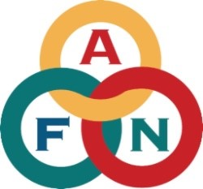

2024 President’s Award – Nomination Form

Organizer Information: (AFN will contact you if your nominee is selected.)

Organization: ________________________________Attn: ____________________________

Email: ______________________________________Phone: __________________________

Please check one Award category for which you are nominating:
□Health □Eileen Panigeo MacLean Education
□Hannah Paul Solomon “Woman of Courage” □Katie John Hunter-Fisher
□Roger Lang Youth Leadership □Small Business
□Gin’tith (Richard Frank) Military Service □Glenn Godfrey Law Enforcement

1. Who are you Nominating?

Name Phone:

Address City: State: Zip:

Email

Tribal Affiliation

2. Information on family history, siblings, place of origin, etc.:

3. Activities National/Statewide/Local:

4. Please provide information on special talents, skills and past experiences relevant to the designated award category:

5. Please provide distinctive quotes, well-known guidance given, or any other information that is exclusive to the Nominee:

6. Biography: 250 words or less

7. Please attach a photo:

