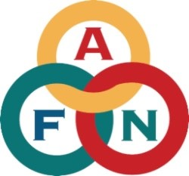

2024 President’s Award – Nomination Form

Please check one Award category for which you are nominating:
□ Health □ Eileen Panigeo MacLean Education
□ Hannah Paul Solomon “Woman of Courage” □ Katie John Hunter-Fisher
□ Roger Lang Youth Leadership □ Small Business
□ Gin’tith (Richard Frank) Military Service □ Glenn Godfrey Law Enforcement

1. Who are you Nominating?

Name

Address

City, State, Zip

Phone or Cell

Email

Tribal Affiliation

2. Information on family history, siblings, place of origin, etc.:

3. Activities National/Statewide/Local:

4. Please provide information on special talents, skills and past experiences relevant to the designated award category:

5. Please provide distinctive quotes, well-known guidance given, or any other information that is exclusive to the Nominee:

6. Biography: 250 words or less

7. Please attach a photo below:

Required Organizer Information: (AFN will contact you if your nominee is selected.)

Organization

Address

City/State/Zip

Phone

Email

Deadline: Wednesday, August 14, 2024

Submit by mail OR email to: AFN
3000 A Street, Suite 210
Anchorage, AK 99503
ATTN: Nicole James

Phone: 907-274-3611
Email: njames@nativefederation.org

